**Git and Git HUB**

**What is Git : Git is source code management system and maintain the version control.**

**There were 2 types of version control**

1. **Centralized version controlling**
2. **Distributed version controlling**



1. **Note: Centralized version controlling system was depreciated.**

**What is Git bash: Git bash is terminal to run the git commands.**

**How to install Git**

1. **Download the software from Git official site**

[**Git - Downloading Package (git-scm.com)**](https://git-scm.com/downloads/win)

**Install the Git bash with default options as per on-screen instructions.**

**Git Process:**

**Working Directory staging Local Repository**

**How make working directory: Git init command make was working directory called as master directory.**

**Git init**

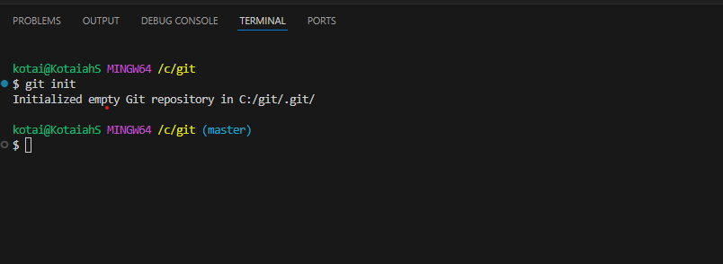

**How to move files from master to staging**

**Command : git add < file name >**

**Git add .**

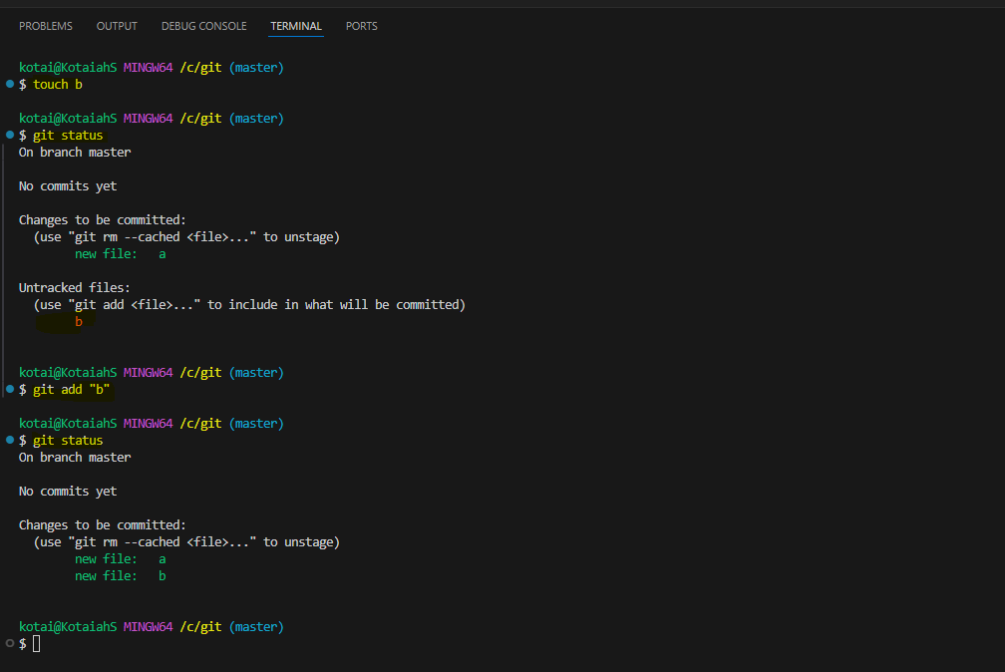

**How to move the file from staging to local repository**

**Command : git commit -m “name “**

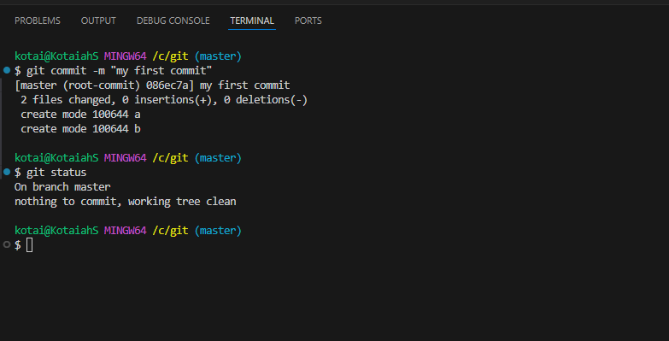

**Git Branching : To maintain source code from different projects recommended to cerate the branches.**

**Command :**

* **git branch test**
* **Git checkout test**

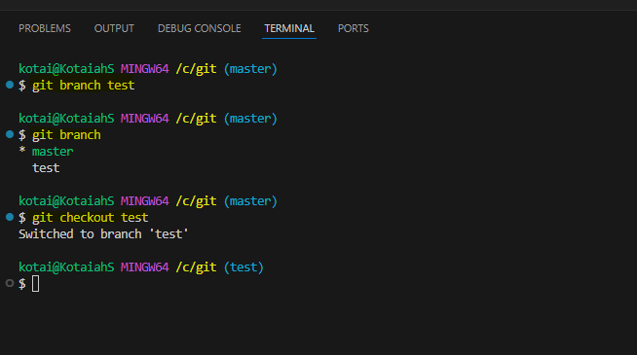

**Merge Branch: git merge is used to combine two branches.**

**When we merge the child branch to parent branch, the merge showing as latest commit.**

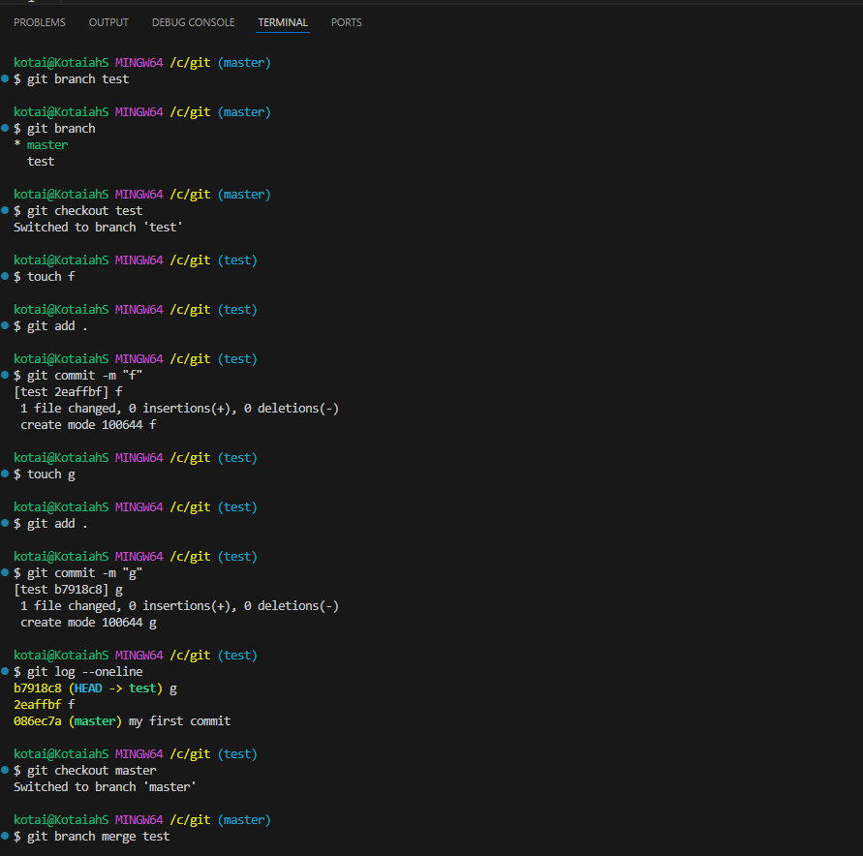

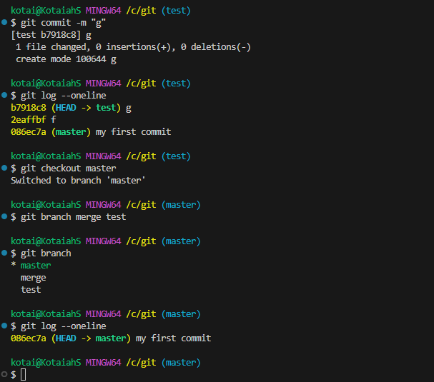

**.git ignore : when we compiling or validating source code like “java, terraform” will be creating extra file like .tfsate, .sh and these file are not pure source code.**

**To push the only pure source code into local repository required to use .git ignore file to exclude unwanted files.**

**Steps : 1) create .gitignore file (touch .gitignore)**

1. **Update the wild card for unused file ( vi .gitignore)**

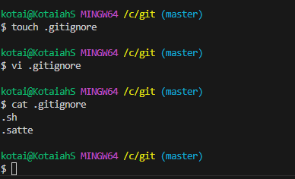

**Git Rebase: Git rebase called as fast forward merge**

**Commits are picked up from child branch and added into master branch as latest commits.**

**Advantages of rebase : 1) picked the top commits**

**2)Rearrange commit order**

1. **Merge the commits**

**Command : checkout sub branch (git branch <branch Name>**

* **Git rebase master**
* **Git checkout master**
* **Git merge test1**

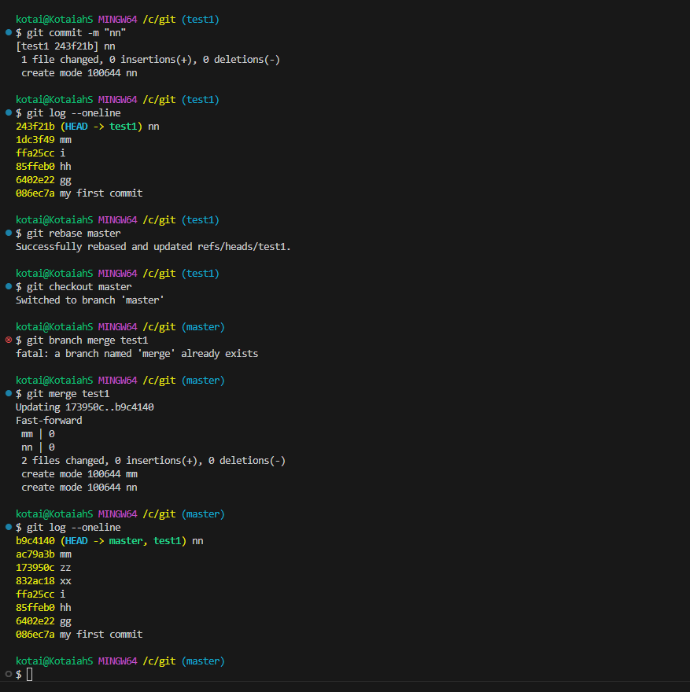

**Re arrange the commits: to change the commit order.**

**We cannot change the first commit order.**

**Command – git rebase -I HEAD~2(commits)**

**Merge Commits : to remove the unnecessary commits.**

**Steps : squash**

* **Git rebase -i HEAD~1**
* **Replace the word with “squash” against commit ID**

**Pickup selective commits from child branch:**

* **Collect commit id from child branch**
* **Checkout to master branch**
* **Run command “ git cherry-pick <commit ids>**

**Amend : Amend command used changes amend to existing commit when modify the source code.**

**Git commit -amend -m “commit name>**

**Roolback to previous version :**

* **Collect the commit id**
* **Git reset –hard <commit id>**

**GitHub : GitHub is remote repository and common centralized repository called as GitHub.**

* **Create github account**
* **Sign in**
* **Create repository**